Wafer Production Line - Optimization

# TPK4186 - Advanced Tools for Performance Engineering Assingment 3: Wafer Production Line

## Created by: Christian G Kartveit & Skjalg Nysaeter

# 2.3 Optimization

# Task 5.

## Simulation with Worst Case

This is an example of runtime with the worst case solution. One batch is loaded into the simulation, and the next one is not loaded until the first one is finished. This is repeated until all 1000 wafers is produced. The batch sizes is random from 20 to 50 wafers per batch, and therefore some variation in time between each run. The total runtime is: 17963.0 minutes for this simulation.

## Simulation with reduced loadtime between batches

Now we will try to reduce the loading time between the batches. We will simulate 3 simulations, with batch sizes of 20, 50 and random batch size. The graphs below will show the loading times, and the finish time for all 1000 Wafers. The loading time between each batch is increased with a constant number, and the loading time between each batch is the same as the number of simulations. The loading time between each batch is increased from 1 to 300 minutes.

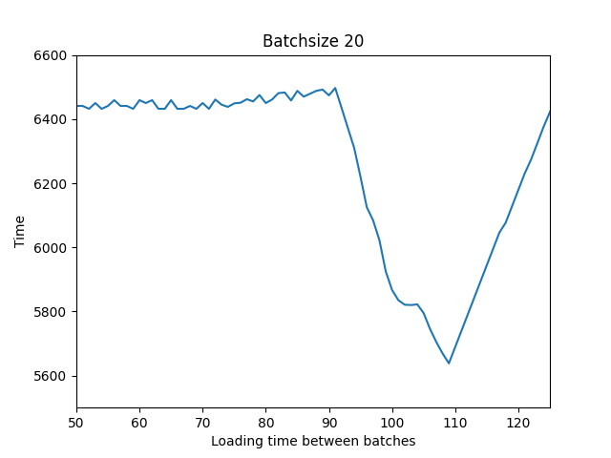

Batchsize 20: The optimal solution is with total time: 5638.0 and loading time between batches 109 minutes.

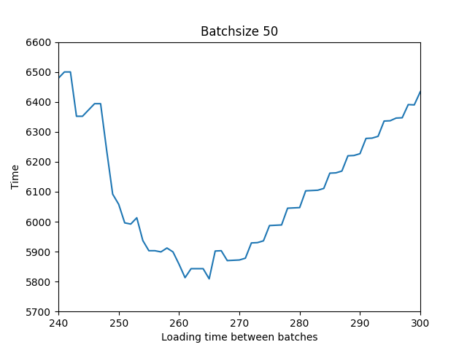

Batchsize 50: The optimal solution is with total time: 5809.0 and loading time between batches 265 minutes.

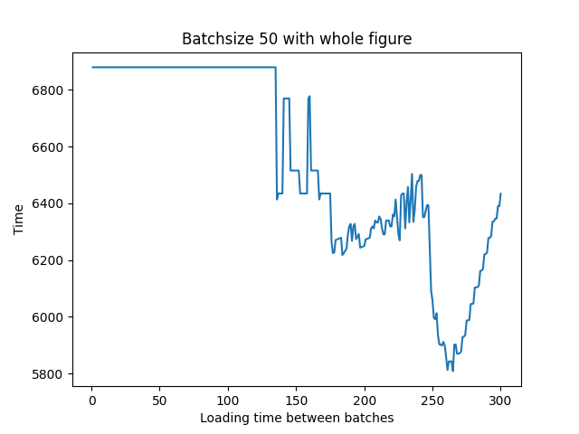

Observe that the optimal loading time between each task from batchsize 20 and batchsize 50 is proportional to the batchsize.

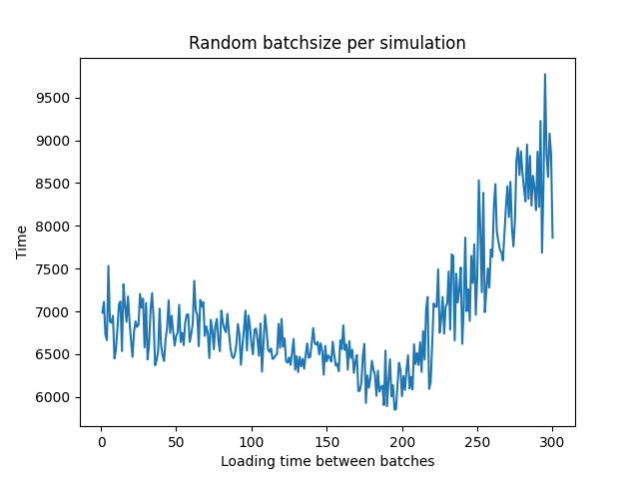

Batchsize 20: The optimal solution is with total time: 5852.0 and loading time between batches 195 minutes. NOTE: With random batchsize, the optimal solution is likely to change from run to run.